**Assimilation of Preemptive Model on Accident Locations on Indian Roads**

*G Sai Krishnan*

*Associate Professor*

*Department of mechanical engineering*

*Rajalakshmi Institute of Technology*

*Chennai, India*

[*saikrishnan.g@ritchennai.edu.in*](mailto:saikrishnan.g@ritchennai.edu.in)

*Dr A.Arthi*

*Head of Department*

*Department of Artificial Intelligence and Data Science*

*Rajalakshmi Institute Of Technology*

*Chennai, India*

[*arthi.a@ritchennai.edu.in*](mailto:arthi.a@ritchennai.edu.in)

*O Pandithurai*

*Associate Professor*

*Department of Computer Science and Engineering,*

*Rajalakshmi Institute of Technology,*

*Chennai, India*

[*pandics@ritchennai.edu.in*](mailto:pandics@ritchennai.edu.in)

*Mohammed Naveed Shariff R*

*Artificial Intelligence and*

*Data Science*

*Rajalakshmi Institute of Technology*

*Chennai, India*

[*mohammednaveedshariff.2021.ad@ritchennai.edu.in*](mailto:mohammednaveedshariff.2021.ad@ritchennai.edu.in)

[*https://orcid.org/0009-0008-5288-6911*](https://orcid.org/0009-0008-5288-6911)

*S Vivek*

*Assistant Professor*

*Department of Mechanical Engineering,*

*Rajalakshmi Institute of Technology,*

*Chennai, India*

[*vivek.s@ritchennai.edu.in*](mailto:vivek.s@ritchennai.edu.in)

*Nachiar S*

*Artificial Intelligence and*

*Data Science*

*Rajalakshmi Institute of Technology*

*Chennai, India* [*nachiar.s.2021.ad@ritchennai.edu.in*](mailto:nachiar.s.2021.ad@ritchennai.edu.in)

[*https://orcid.org/0009-0006-3530-791X*](https://orcid.org/0009-0006-3530-791X)

***Abstract*—*In this paper, we have solved the Spatial Heterogeneity by the preemptive model using the ORS’s API. Black Spot locations are gathered and then visualized in the Indian States, It concludes 92% of accidents are caught on Black Spots in Maharashtra in 2018. According to the research made on “Education Influence on Traffic Safety '' in Vietnam. It stated that the preemptive approach before accidental situations may reduce 70% of accidents. So we use a Precaution model to indicate the Black Spot zones to the driver. This is how we can drag down 70% of accidents in Black Spots.***

***Keywords—Black Spots, Road Accidents, Precaution model, Traffic Safety Education.***

1. **INTRODUCTION**

Black Spots are areas of the road network that have a high number of accidents or deaths. These hotspots are often identified based on a history of repeated incidents and are distinguished by poor road design, inadequate signage, inadequate illumination, or other characteristics that lead to an increased risk of accidents. Black spots are a key source of worry for road safety officials, and they are being targeted for improvement and corrective actions in order to decrease accidents and save lives. Identification and correction of black spots need extensive research and analysis of accident data, traffic flow patterns, road conditions, and other pertinent elements. The Ministry of Road Transport and Highways, as well as state-level authorities, work together to identify, prioritize, and implement steps to eradicate or decrease black spots across the country. This continual practice of detecting and repairing black spots helps to improve road safety and reduce accident rates in India. In order to visualize and find the accidental locations in India we took inspiration from the visualization made by our government with 2018 data. Using different visualization tools and analysis we conclude the probability of getting accidents when we use the Black Spot roads.

Prediction models have been built and used for the past 5 decades, models like Liner Regression, Logistic Regression, Decision Tree, Simple Vector Machines, Gradient Boosting, etc are used for making road accident predictions. They were accurate when it comes to singular prediction but when it comes to global data the model’s accuracy drastically reduces because of the Spatial Heterogeneity. According to the research made on [1]“Education Influence on Traffic Safety” and [2]“Effect of road safety education on road risky behaviours of Spanish children” says precaution notification before any occurrence incidents will likely reduce 70% to 76% of road accidents. We built a model based on this preemptive approach which will indicate the driver for the call of precaution if they enter into a Black Spot Zone.

1. **LITERATURE SURVEY**

Because of its potential to improve road safety, the prediction of traffic accidents using machine learning techniques has received a lot of interest. To construct predictive models, researchers investigated numerous methods such as decision trees, neural networks, support vector machines, and random forests. These models make use of historical accident data as well as important elements like road characteristics, traffic density, weather conditions, and driver-related factors. Machine learning algorithms can learn to forecast the likelihood of accidents in certain areas or under specific situations by analyzing patterns and relationships within the data. Engineering and feature selection are critical in identifying the primary aspects that lead to accident occurrence. The relevance of temporal aspects in capturing accident patterns, as well as the requirement for real-time data integration for more accurate forecasts, has also been emphasized by researchers. Accurate accident prediction models can help in proactive accident prevention by employing machine learning techniques, allowing authorities to take targeted actions, enhance road infrastructure, and execute safety interventions to reduce the frequency and severity of accidents. We found that most of the models with deficiencies that reduce the usage of the models and the main reason is due to Spatial Heterogeneity. This is found when we implement our model globally. So to tune up the accuracy, the preemptive model is used and it will notify the driver whenever they are travelling in a Black Spot.

1. **OBJECTIVE**

This paper is dissected into four divisions, First is Data Collection. Data has been cited from the *Ministry of Road Transport and Highways* where we fetched all the information about blackspots then we generalized it to every state of the country. Then Data Visualisation, using software like QGIS, Tableau and PowerBI we made the data into infographics and maps which showed us in 2018, the Indian state Maharashtra's major accidents up to 92% occurred in the blackspot regions. The final stage is when we found a way of reducing 75% of accidents in black spots. Now let’s see each stage with a detailed view.

**3.1. Geo Mapping**

First, we gathered information about no.of black spots on highways state wise and then with the help of OpenStreetMap(OSM) and Tableau we visualized and marked the plots.

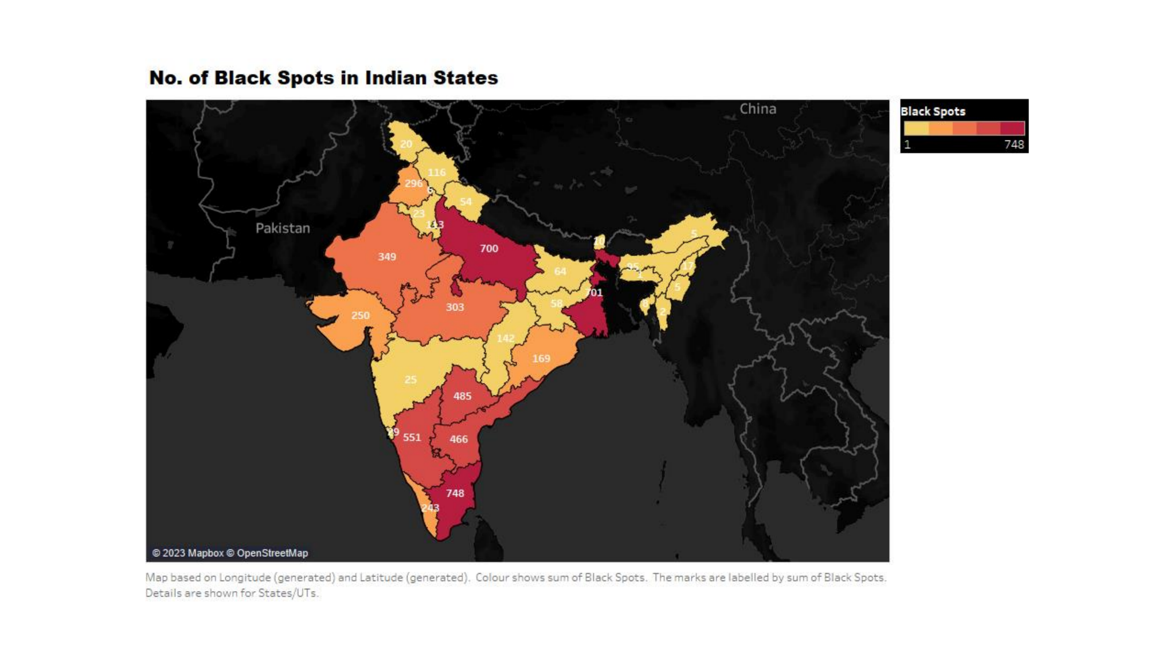

**Fig. 2.1.** No. of Black Spots in Indian States

Then we found the percentage of getting accidents specifically in the Black Spot region. This was done by taking the overall accidental data of every state and finding the percentage of accidents that occur only in Black Spot regions.

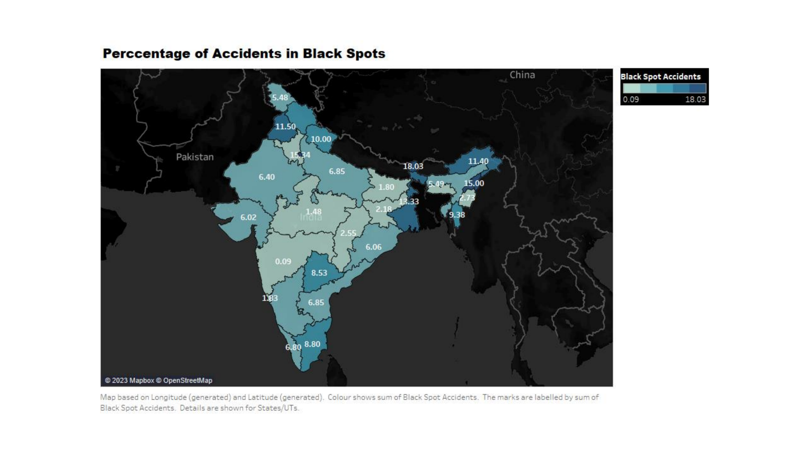

**Fig. 2.2.** Percentage of Accidents in Black Spots

This led us to find the probability proportion of getting into an accident whenever we use Black Spot(BS) roads. This was calculated by marking up the correlation between the “No. of Black Spots(BS)” and “No. of maximum accidents that occurred in the Black Spot area”. This shows the awareness for not using the Black Spot roads while travelling.

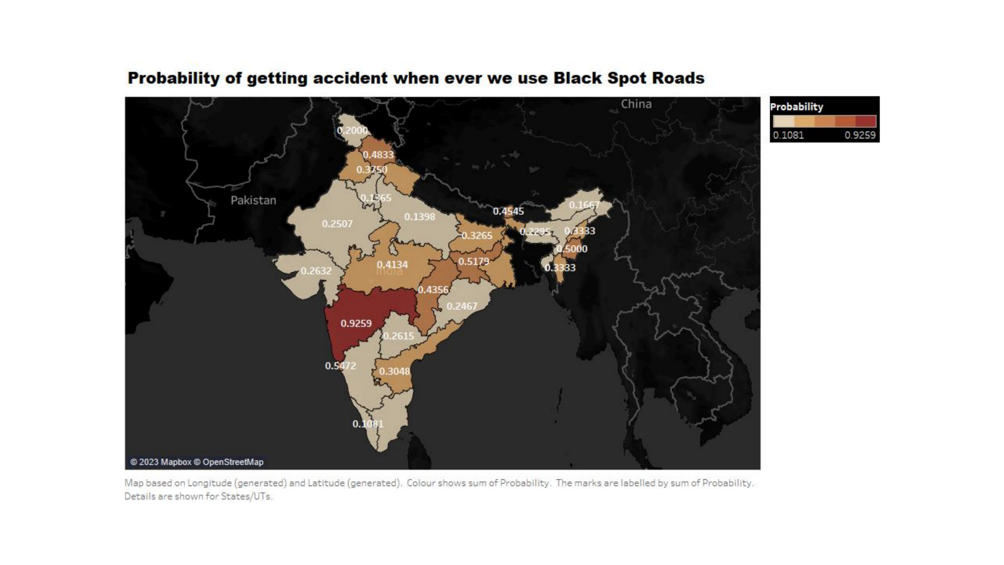

**Fig. 2.3.** Percentage of Accidents in Blackspots

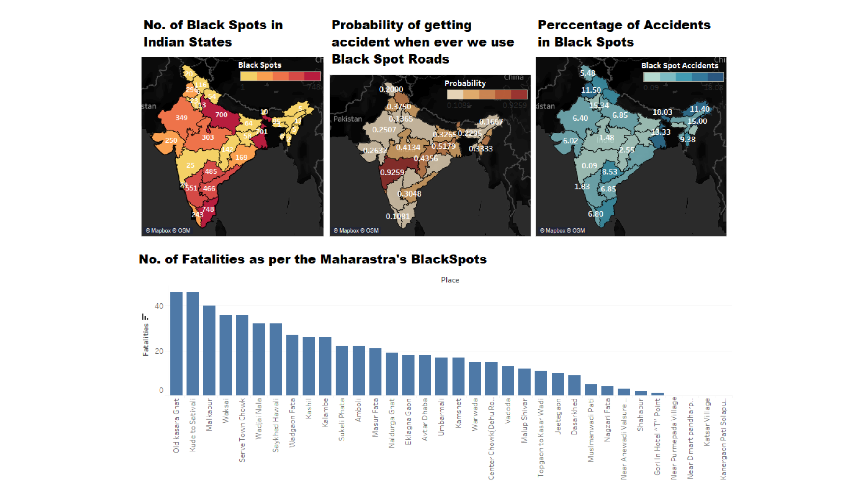

**Fig. 2.4.** Overall Visualization   
  
From ***Fig. 2.3.***we can say that Maharastra State suffered nearly 92% of accidents only in the black spot region during 2018. In the next stage, where we prepared the Maharashtra State map using qGIS software. Black Spots are marked using attributes such as Area Name, Longitude and Latitude.

**3.2. Mapping using qGIS**

Now we precisely focus on the Maharashtra map because it shows the high probability of accident occurrence. We use QGIS (Geographic Information System) to visualize and map the accident roads. We can see the mapped roads in the given image below.

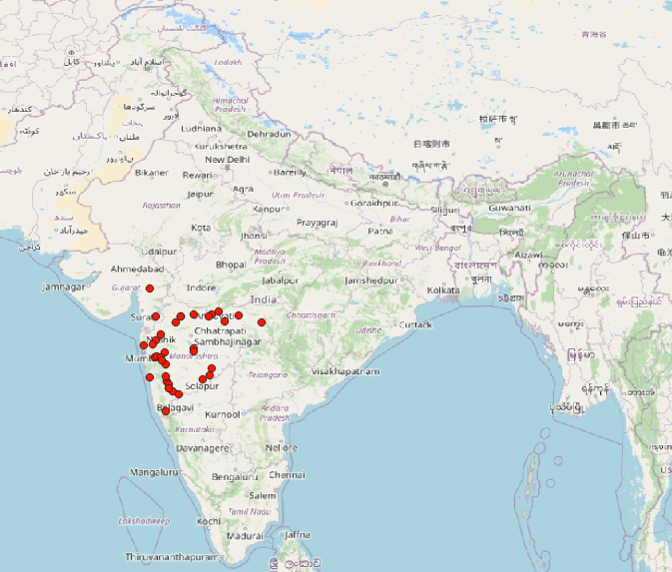

**Fig. 2.5.** Outview of Black Spots in Maharashtra

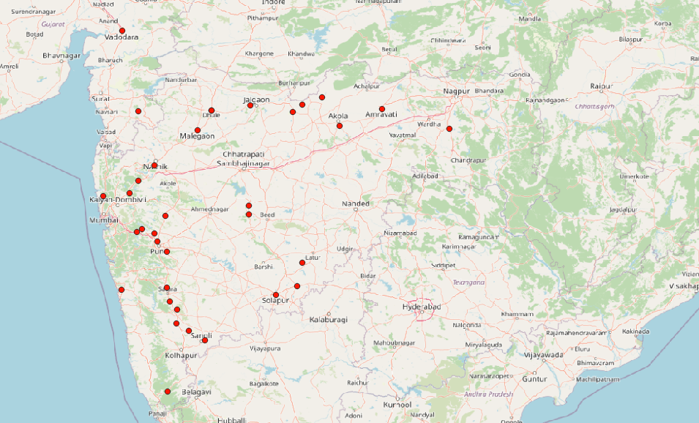

**Fig. 2.6.** Close view of Black Spots in Maharashtra

**3.3. Infographic Visualization**

Finally, we plot the major Black Spot roads of Maharashtra by stating to avoid them because of the high chances of being involved in accidents. Then we see the major reasons for getting into accidents. 32% of accidents occur because of Vehicle Speeding and it has caused 243 Accidents and 151 Fatalities. The minimum here is Drunk and Drive which cost 3 lives in the year 2018 on the road of (Sukeli Phata), which is also a low-light area.

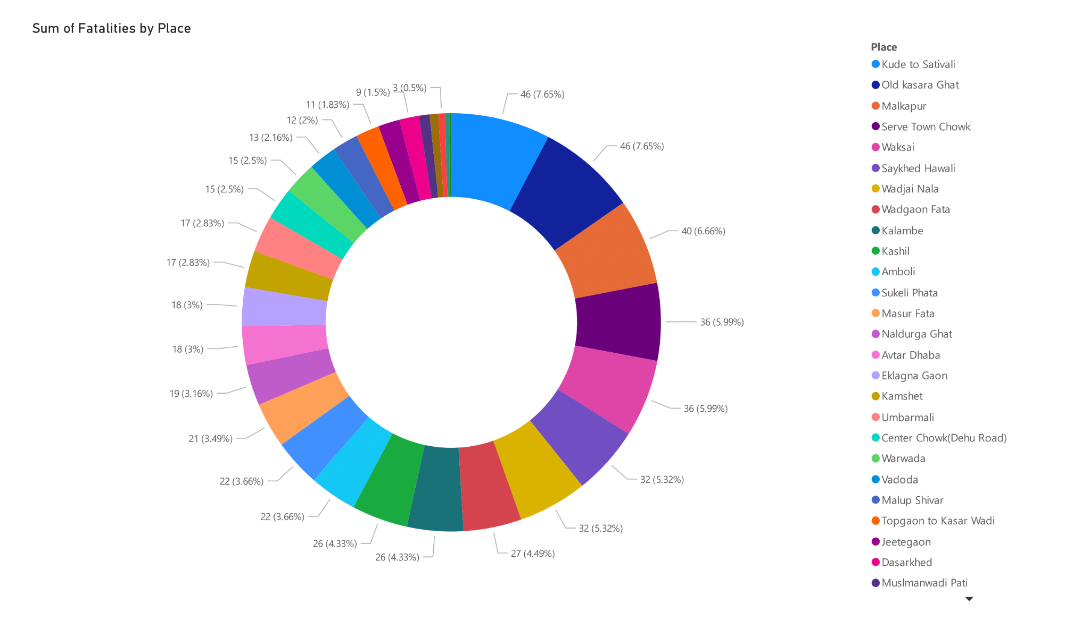

**Fig. 2.7.** Percentage of Accidents in all Black Spots

Then we visualized the grounds for getting into the accidents.   
***Fig. 2.8.***says 60% of the accident is caused due to Vehicle Speeding and then comes to Critical Turning. Due to these issues, a driver needs to be alert when he is in the Black Spot zone. A study [2] on Preemptives of Traffic Alerts has controlled accidents up to 75%, So we enforced a model which works based on the provoking system when the driver meets the black spot zones in the map.

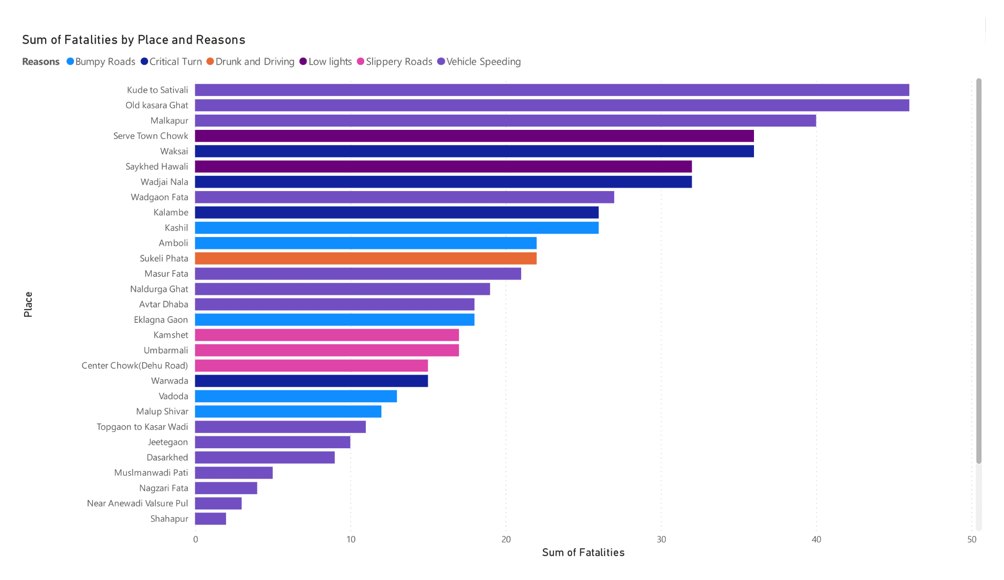

**Fig. 2.8.** Sum of Fatalities by Place and Reasons

1. **OUTCOMES**

Accident prediction models have been utilized by Danish traffic planners and engineers since the beginning of the eighteenth century. The models were built using data from state and county highways, which are mostly found in rural areas. Beginning in the early 1990s, research on accident prediction models for urban junctions and road linkages was encouraged by a growing need for models that could also be utilized for urban roads. The primary goal of this research was to develop practical accident prediction models that would properly represent the predicted frequency of accidents at urban intersections and traffic linkages.

* Global data predictions are challenging, thus this research addressed the issue by providing a Provoking model that serves as the Precaution Alert System (PAS), or Preemptive Alert System (PAS).
* Geo Map Applications are integrated with the Preemptive Alert System (PAS), which displays the Black Spot Zones.
* To determine whether the system needs to push an alert or not, logistic regression is employed. The driver is in the Black Spot Zone if the value is 1, and out of the Black Spot Zone if the value is 0.

1. **CHALLENGES**

Since more than 50 years ago, accident road analysis and prediction have been studied and used. Since all governments have been working on traffic and accident management for years, it is simple to determine that every model has been deployed and tested to the fullest extent possible. But when it comes to the implementation portion, the location is the key issue. Because the model would just need to solve a certain road with the most characteristics, commissioning a specialized model may be done easily. This complicates time and space and reduces the model's accuracy.

Although it performs well for single forecasts, we are unable to apply the model to all roads since the values of each attribute fluctuate. Instead, values for variables like road size and driver behaviour must be assumed before being recalculated. When it comes to the global values of all characteristics, data like road size, driver conduct, lane following, etc. will be quite expensive. The solution to this problem was difficult, and it presented us with a difficult experience that required hours to days of diligent inquiry.

1. **ARCHITECTURE**

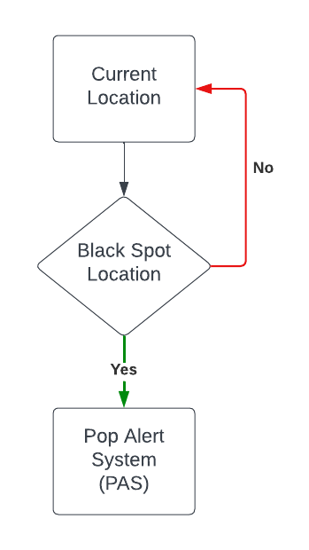

**Fig. 6.1.** Pop Alert System (POP)

The motorist will be forced to maintain attention and be aware of their surroundings until they leave the black patch thanks to this preventative mechanism. This will undoubtedly prevent 70% of the accidents that would have occurred.

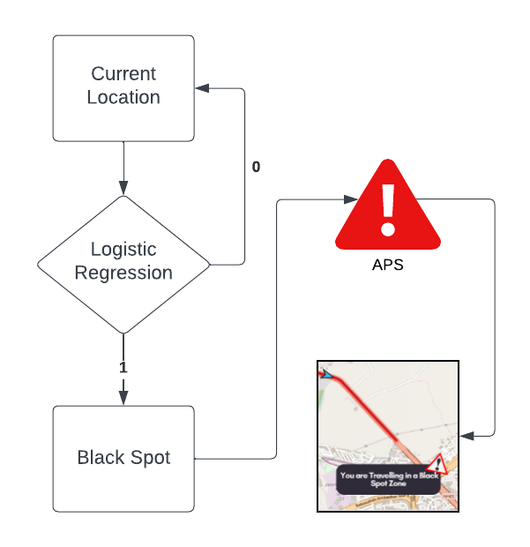

**Fig. 6.2.** Pop Alert System Workings

1. **IMPLEMENTATION**

**7.1. Assimilation of Black Spot Zones in Maps**

Using the ORS API in the qGIS software, Black Spot Zones are plotted on a map in *fig.7.1.* Demonstrates the Black Spot mapping in neon red. On our maps, we can locate it with ease. so that the driver may drive with greater caution.

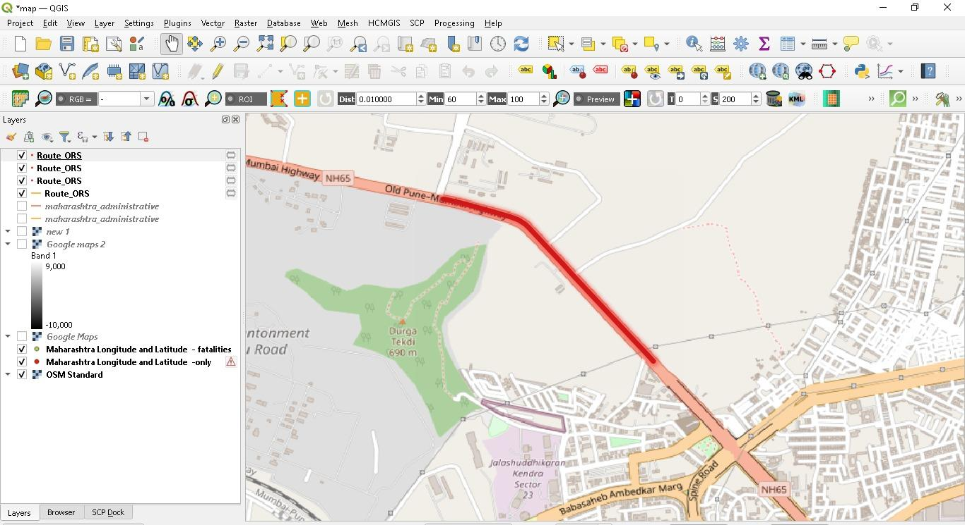

**Fig. 7.1.** Black Spot Zone shaded in Neon Red

For guaranteeing road safety and lowering the chance of accidents, tracking blackspots on maps is tremendously important. Black spots are spots on roadways or at crossroads where a lot of accidents or other events have happened in the past. It is made simpler for authorities, cars, and pedestrians to be aware of these regions and take the necessary measures by identifying and tracking these blackspots on maps. Maps may be used to illustrate the information about blackspots and give a visual depiction of these high-risk regions. Users may then arrange their journeys appropriately, avoiding blackspots or travelling through them with additional caution. Drivers can reduce the chance of accidents by adjusting their speed, paying more attention to traffic laws, and being more cautious when they are aware of blackspots in advance.

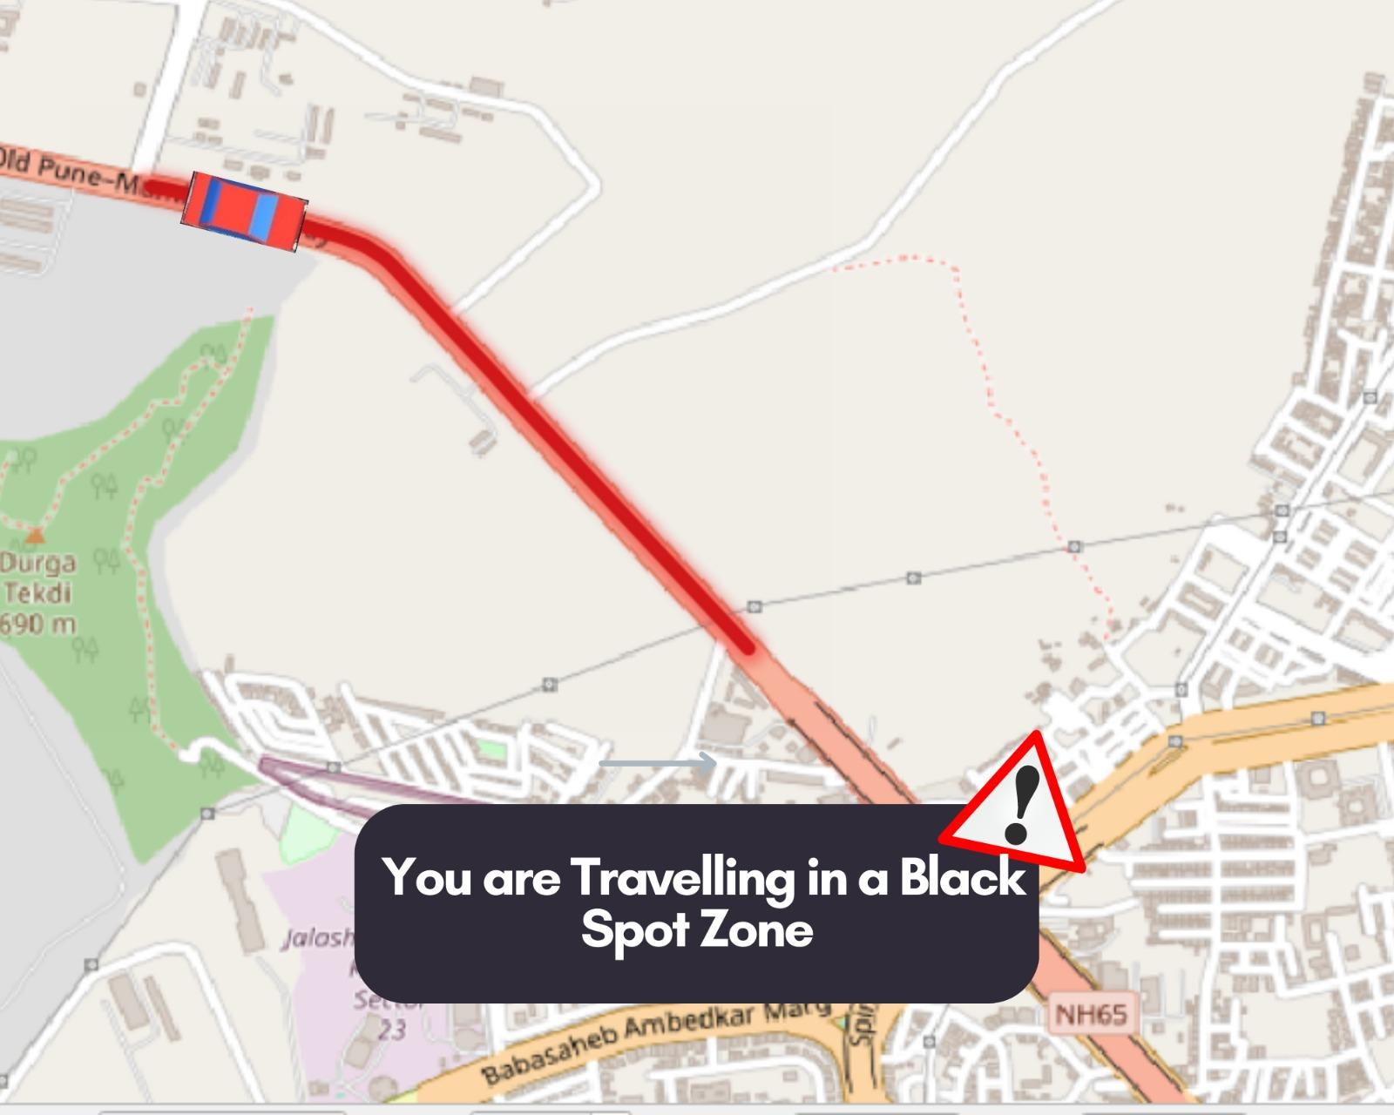

**Fig. 7.2.** Preemptive Alert System (PAS)

Tracking blackspots on maps is helpful for traffic management and urban planning, in addition to individual drivers. It makes it possible for transportation authorities to pinpoint trouble spots and implement targeted safety elements like better road infrastructure, signs, and traffic signals. Authorities may more efficiently deploy resources and put preventative measures in place to deal with the unique problems these communities confront by concentrating on blackspots. Additionally, tracking blackspots on maps offers useful information for statistical analysis and study. Researchers can learn more about the underlying variables, patterns, and trends that result in accidents in particular areas by examining accident data connected to blackspots. This information may direct the creation of more thorough road safety plans, focused interventions, and policy choices meant to lower accidents and enhance overall road safety.

**7.2. Binary Regression for Zone Matching**

The Precaution model using Binary Regression is used since the goal is to increase driver awareness. Whenever the driver enters a Black Spot Zone, an Alert will be sent to them. The specific operation is described as follows: The first step is to make the data single, thus we multiply the current location's latitude and longitude. Then, the unique information about the Black Spots has already been provided to the machines and is kept in the attribute called Accident Locations. The output will be 1 if the current position is equal to one of the accident sites. We will receive an output of 0 if our current location does not match any of the accident locations.

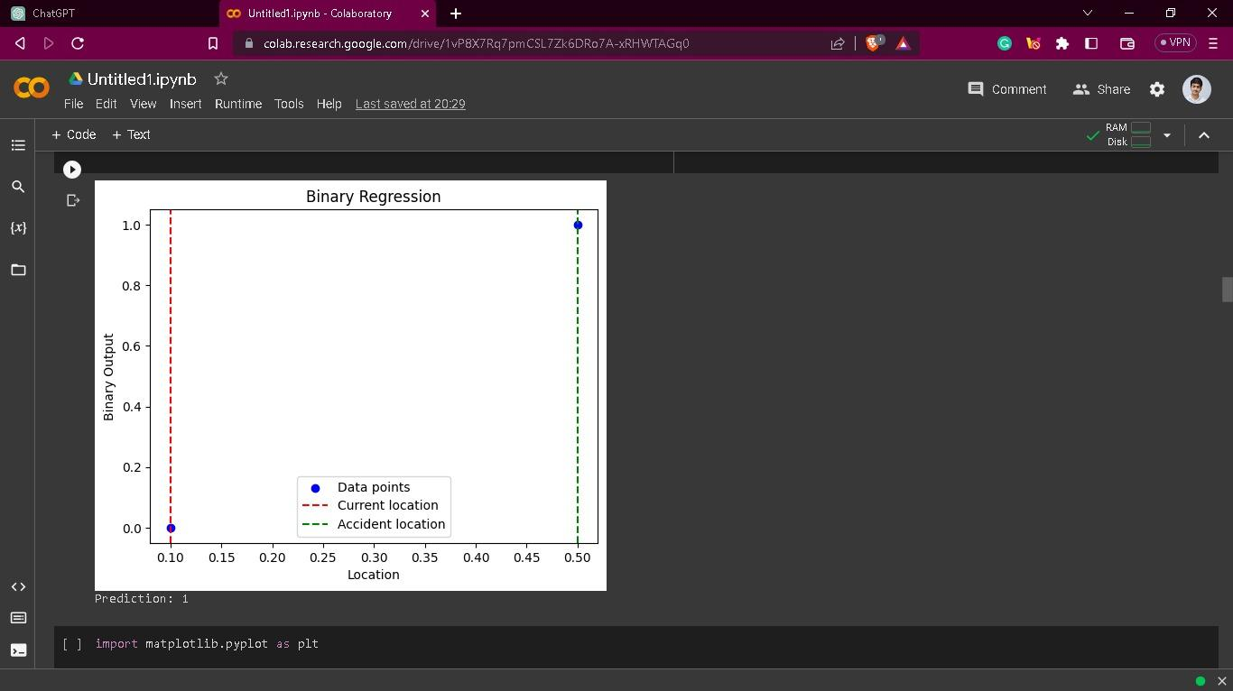

**Fig. 7.3.** Binary Regression of the Model

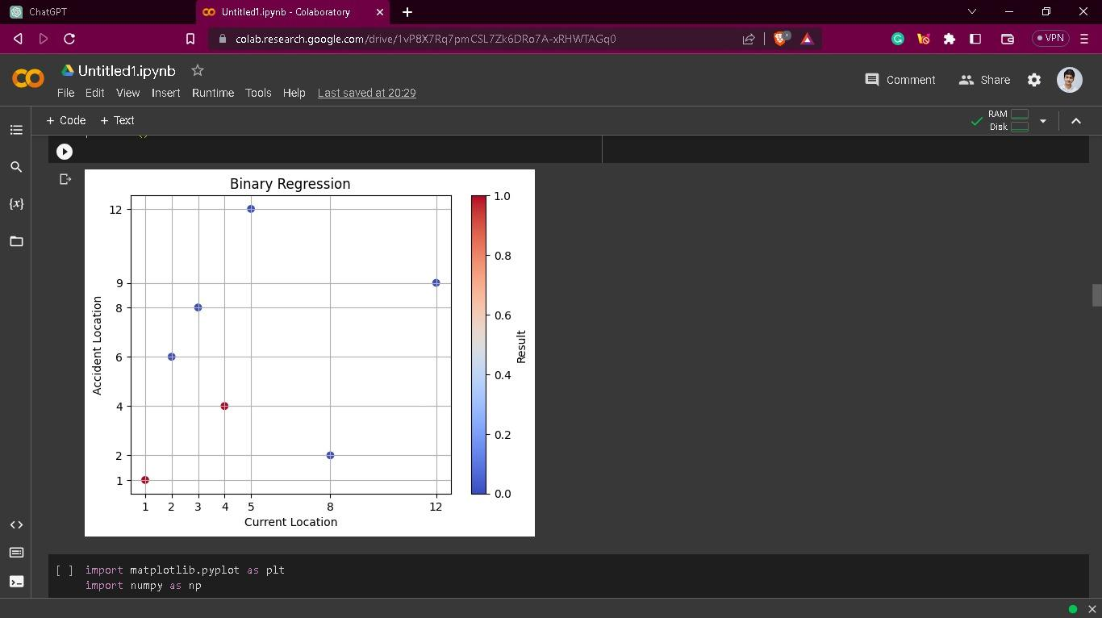

**Fig. 7.4.** Precise Regression of the Model

**7.3. Integrating Precaution Model in Maps**

Now the entire code is fitted into a mode with a PAS system made using Tkinter Python for the Popups in maps. The following code shows the Binary Regression fitting into the model.

import tkinter as tk

from tkinter import messagebox

# Function to handle button click event

def check_location():

# Get latitude and longitude values from entry fields

latitude = float(latitude_entry.get())

longitude = float(longitude_entry.get())

# Calculate current location

current_location = latitude * longitude

# Check if current location matches any accident locations

accident_locations = [1414.106581,1445.3516,1535.162324,1378.413458,1604.557044,1363.266375,1622.237163,1626.143559,1299.177803,1408.648555,1181.189563,1471.393358,1290.370057,1358.948147,1450.983924,1584.406207,1299.316246,1383.635946,1391.958978,1383.025287,1632.978629,1589.949045,1373.553804,1532.294836,1591.877805,1438.874592,1266.335214,1271.954637,1340.500722,1563.111408,1426.268612,1316.236594,1628.503396,1563.030356,1258.536798,]

if current_location in accident_locations:

messagebox.showinfo("Alert", "You are currently in Black Spot Zone, Be cautious!!", icon="warning")

status_label.config(text="Status: High Risk", fg="red")

else:

messagebox.showinfo("Alert", "Safe Zone", icon="info")

status_label.config(text="Status: Safe", fg="blue")

# Create the GUI window

window = tk.Tk()

window.title("Binary Regression")

window.geometry("300x200")

# Create latitude label and entry field

latitude_label = tk.Label(window, text="Latitude:")

latitude_label.pack()

latitude_entry = tk.Entry(window)

latitude_entry.pack()

# Create longitude label and entry field

longitude_label = tk.Label(window, text="Longitude:")

longitude_label.pack()

longitude_entry = tk.Entry(window)

longitude_entry.pack()

# Create check button

check_button = tk.Button(window, text="Check Location", command=check_location)

check_button.pack()

# Create status label

status_label = tk.Label(window, text="Status:")

status_label.pack()

# Start the GUI event loop

window.mainloop()

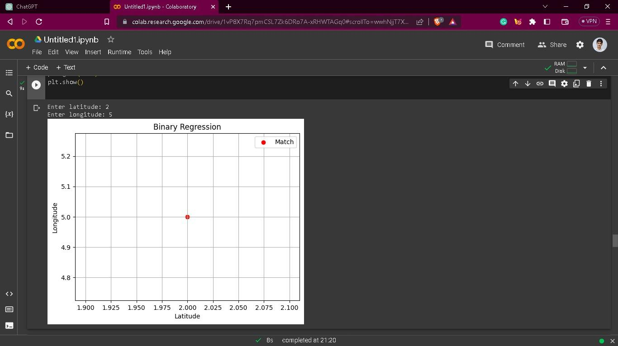

**Fig. 7.5.** Positive for Accidents

The data point is represented by a red dot in this graph, which is displayed and has the legend read "Match" because the current location is the same as one of the accident locations. The data point will be displayed with a blue hue and the notation "No Match" when the current location is not equal to at least one accident location.

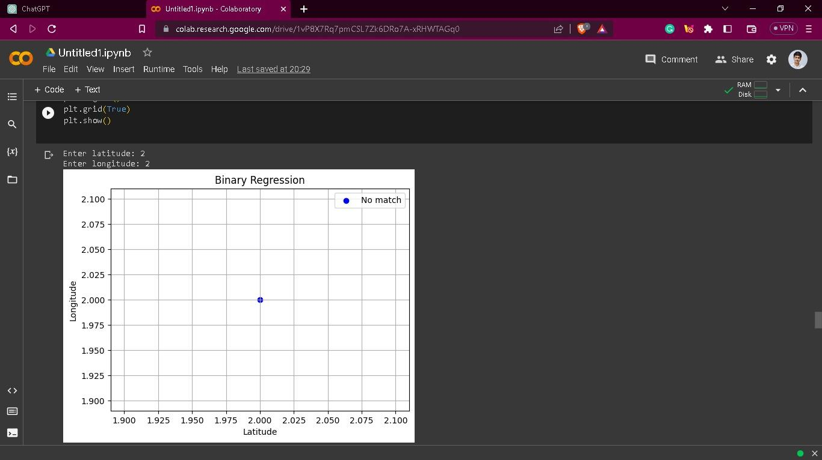

**Fig. 7.6.** Negative for Accidents

We can reduce accidents by up to 75% if the model is successfully deployed on the web using Tkinter and Flask. We will then receive real-time notifications from the map.

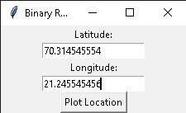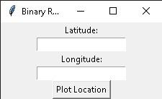

**Fig. 7.7.** Conversion into Singular Data

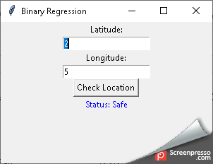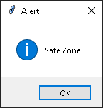

**Fig. 7.8.** Predicting Safe Zones

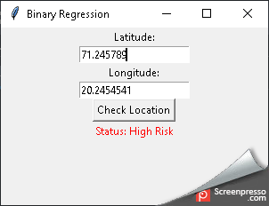

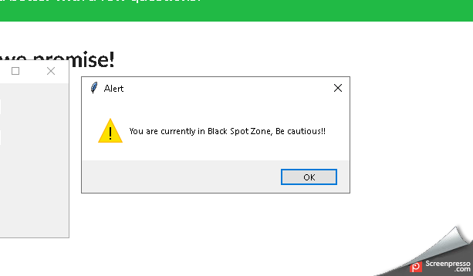

**Fig. 7.9.** Risk Zone Popouts

1. **CONCLUSION**

This paper addresses the issue of road accidents in Black Spot zones and proposes a preemptive approach using a Precaution model to mitigate the occurrence of accidents. Through the utilization of the ORS's API and visualization techniques, the Black Spot locations in Indian states were identified and analyzed. The research findings indicate that a significant number of accidents, specifically 92% in Maharashtra in 2018, occur in these identified Black Spot areas. To tackle this problem, the paper draws inspiration from studies on the influence of education on traffic safety and the effectiveness of road safety education. By implementing a preemptive approach that notifies drivers about Black Spot zones, the proposed Precaution model aims to reduce accidents by up to 70%. This proactive system enables drivers to take necessary precautions and exercise heightened vigilance while traversing these high-risk areas. The paper emphasizes the importance of identifying and addressing Black Spot locations through continuous research, analysis of accident data, and collaboration between the Ministry of Road Transport and Highways and state-level authorities. By adopting a comprehensive approach that includes visualizations, prediction models, and education-based interventions, road safety officials can significantly improve the overall safety of the road network and decrease accident rates across India.

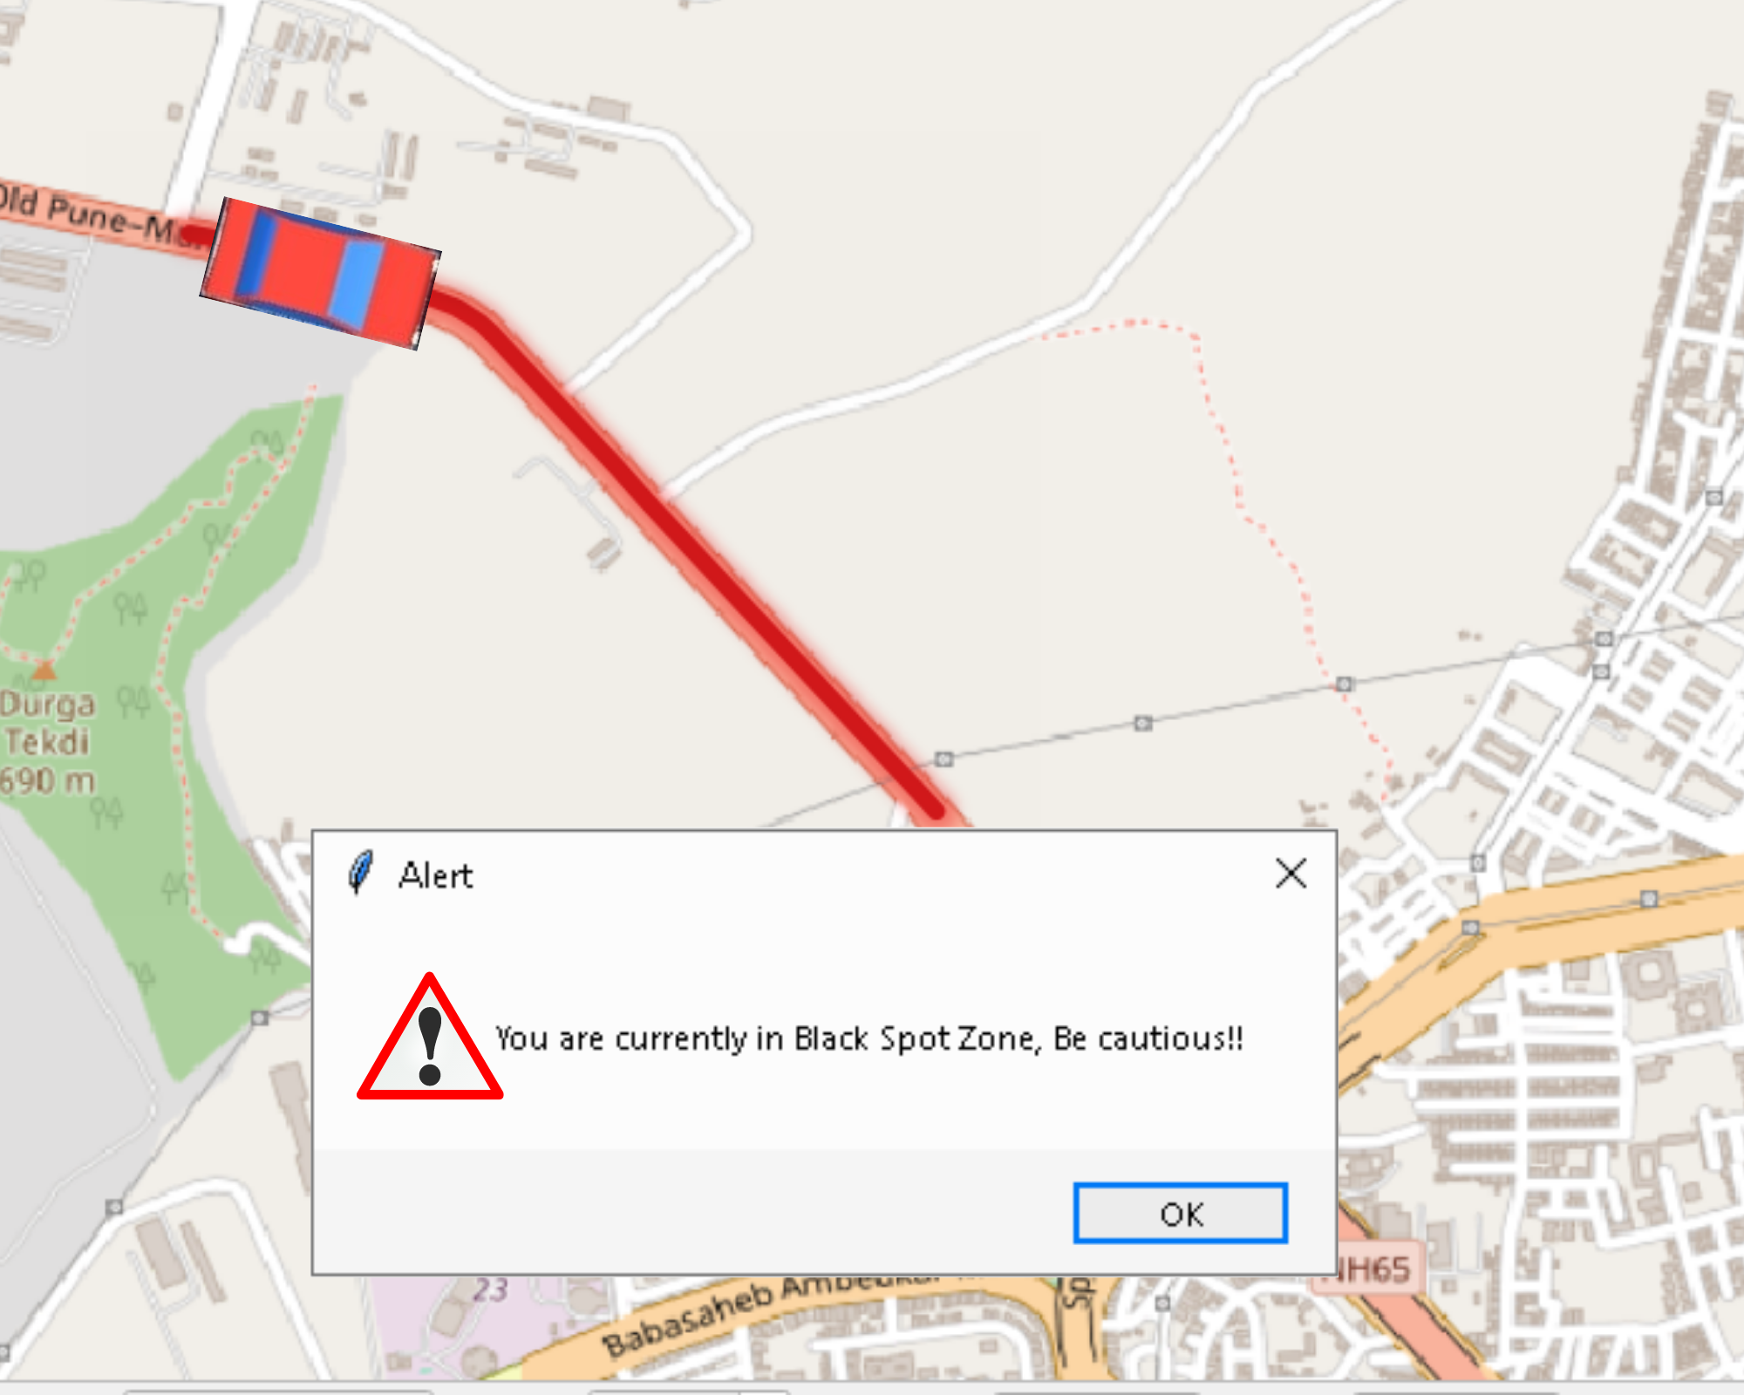

**Fig. 8.1.** Assimilating Final Model

In conclusion, the proposed Precaution model, which leverages preemptive measures and focuses on Black Spot zones, offers a promising strategy to combat road accidents. The findings of this study highlight the potential of proactive safety measures and pave the way for further research and implementation of targeted interventions in order to reduce accidents and enhance road safety.

1. **REFERENCE**

[1] Hung, K.V., 2011. Education influence in traffic safety: A case study in Vietnam. *IATSS research*, *34*(2), pp.87-93.

[2] Alonso, F., Esteban, C., Useche, S. and Colomer, N., 2018. Effect of road safety education on road risky behaviors of Spanish children and adolescents: findings from a national study. *International journal of environmental research and public health*, *15*(12), p.2828.

[3] Alagarsamy, S., Malathi, M., Manonmani, M., Sanathani, T. and Kumar, A.S., 2021, December. Prediction of Road Accidents Using Machine Learning Technique. *In 2021 5th International Conference on Electronics, Communication and Aerospace Technology (ICECA)* (pp. 1695-1701). IEEE.

[4] Shiau, Y.R., Tsai, C.H., Hung, Y.H. and Kuo, Y.T., 2015. The application of data mining technology to build a forecasting model for classification of road traffic accidents. *Mathematical Problems in Engineering*, *2015*.

[5] Ghadi, M. and Török, Á., 2019. A comparative analysis of black spot identification methods and road accident segmentation methods. *Accident Analysis & Prevention*, *128*, pp.1-7.

[6] Cui, H., Dong, J., Zhu, M., Li, X. and Wang, Q., 2022. Identifying accident black spots based on the accident spacing distribution. *Journal of traffic and transportation engineering (English edition)*, *9*(6), pp.1017-1026.

[7] McGuigan, D.R.D., 1981. The use of relationships between road accidents and traffic flow in" black-spot" identification. *Traffic Engineering & Control*, *22*(HS-032 669).

[8] Iqbal, A., Rehman, Z.U., Ali, S., Ullah, K. and Ghani, U., 2020. Road traffic accident analysis and identification of black spot locations on highway. *Civil Engineering Journal*, *6*(12), pp.2448-2456.

[9] Wright, C.C., Abbess, C.R. and Jarrett, D.F., 1988. Estimating the regression-to-mean effect associated with road accident black spot treatment: towards a more realistic approach. *Accident Analysis & Prevention*, *20*(3), pp.199-214.

[10] Karamanlis, I., Kokkalis, A., Profillidis, V., Botzoris, G., Kiourt, C., Sevetlidis, V. and Pavlidis, G., 2023. Deep Learning-Based Black Spot Identification on Greek Road Networks. *Data*, *8*(6), p.110.

[11] Karamanlis, I., Kokkalis, A., Profillidis, V., Botzoris, G. and Galanis, A., 2023. Identifying Road Accident Black Spots using Classical and Modern Approaches. *WSEAS Transactions on Systems*, *22*, pp.556-565.

[12] Prasad, R.R., Suresh, G.L. and Rao, M.Y., 2023, June. Identification, analysis and improvement of accident blackspots: A case study of Narasaraopet mandal, Andhra Pradesh. In *AIP Conference Proceedings* (Vol. 2810, No. 1). AIP Publishing.

[13] Kusumaningrum, R. and Widyaningsih, N., 2023. Analysis of Traffic Accidents Using the Accident Rate Method (Case Study: MT. Haryono Street–Gatot Subroto Street South Jakarta City). *SITEKIN: Jurnal Sains, Teknologi dan Industri*, *20*(2), pp.818-827.

[14] Jayakumara, K.B., Nikhil, T.R. and Lokesh, Y., Identification and Improvements of Accident Black Spots on NH-75 (Nelamangala-Hassan section).

[15] Sisbreño, A.P., Sumilhig, J.A., Venci, T.J.C., Canseco-Tuñacao, H.A.R. and Cavero, D.B.M., 2023, May. Black Spot Identification and Road Accident Prediction Model on Cebu South Coastal Road (CSCR). In *IOP Conference Series: Earth and Environmental Science* (Vol. 1184, No. 1, p. 012022). IOP Publishing.